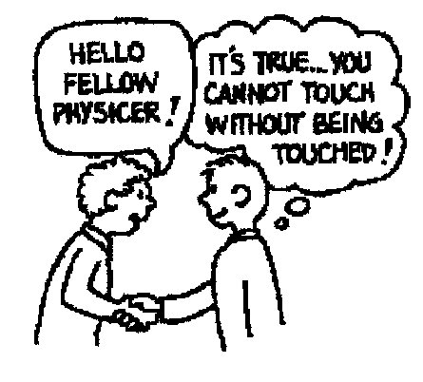**NEWTON’S THIRD LAW**

1. When a hammer exerts a force on a nail, how does the amount of force compare to that of the nail on the hammer?
2. Why does a cannon recoil when it fires a cannonball?
3. When you jump up, does the world recoil downward? Explain.
4. 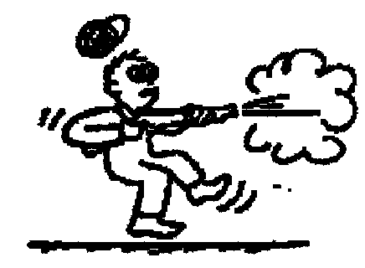Why is it easier to walk on a carpeted floor than on a smooth, polished floor?
5. When a rifle is fired, how does the size of the force of the rifle on the bullet compare to the force of the bullet on the rifle?

- How do the accelerations of the rifle and bullet compare?

1. If a bicycle and a massive truck have a head-on collision, upon which vehicle is the impact force greater?

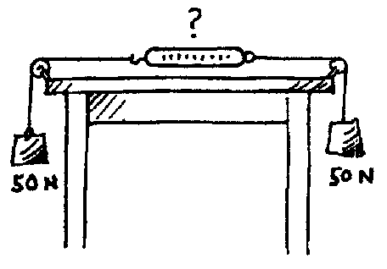

* Which vehicle undergoes the greater change in acceleration?

1. A pair of 50 N weights are attached to a spring scale as shown in the diagram. Does the scale read 0, 50, or 100 N?

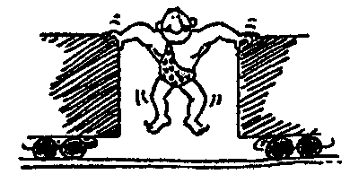

1. The strongman will push the two initially stationary freight cars of equal mass apart before he himself drops to the ground. Is it possible for him to set either of the cars in greater motion than the other? Explain.



1. Suppose two carts, one twice as massive as the other, fly apart when the compressed spring that joins them is released. Afterwards, how do their speeds compare?

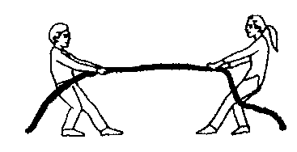

1. Two people of equal mass attempt a tug-of-war with a 12-meter rope while standing on frictionless ice. When they pull on the rope, they each slide toward each other. How far does each person slide before they meet?
2. Suppose in the preceding example that one person has twice the mass of the other. How far does each person slide before they meet?

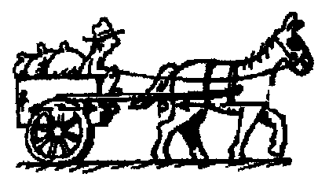

1. A horse pulls a wagon with some force, causing it to accelerate. Newton's third law says that the wagon exerts an equal and opposite reaction force on the horse. How can the wagon move?